Part 2:

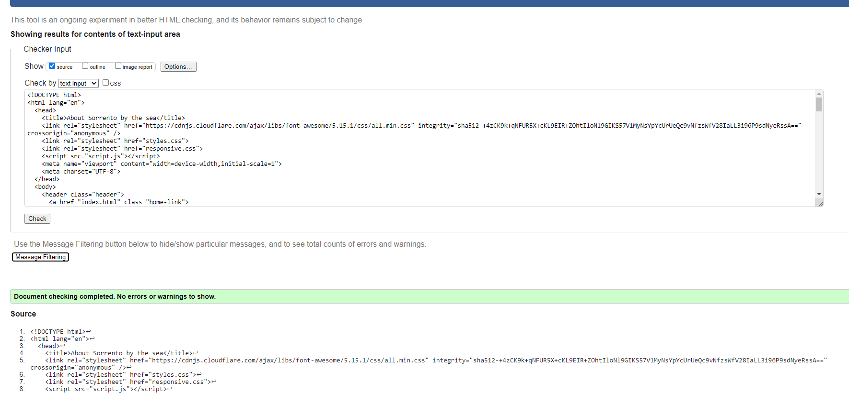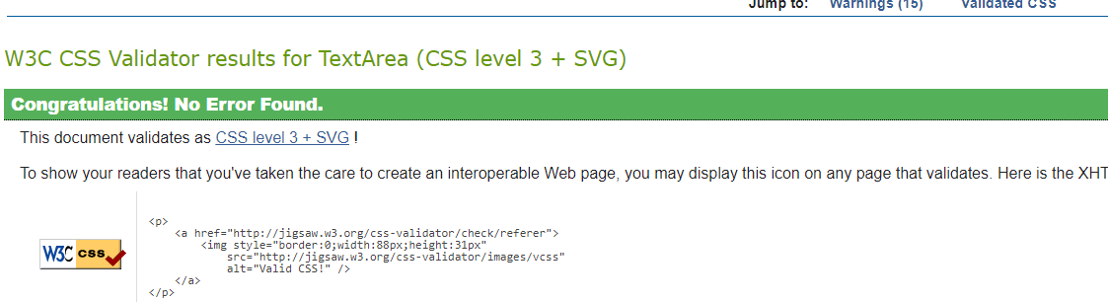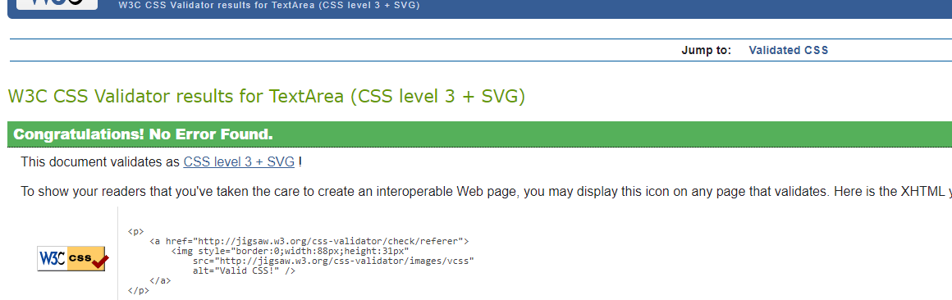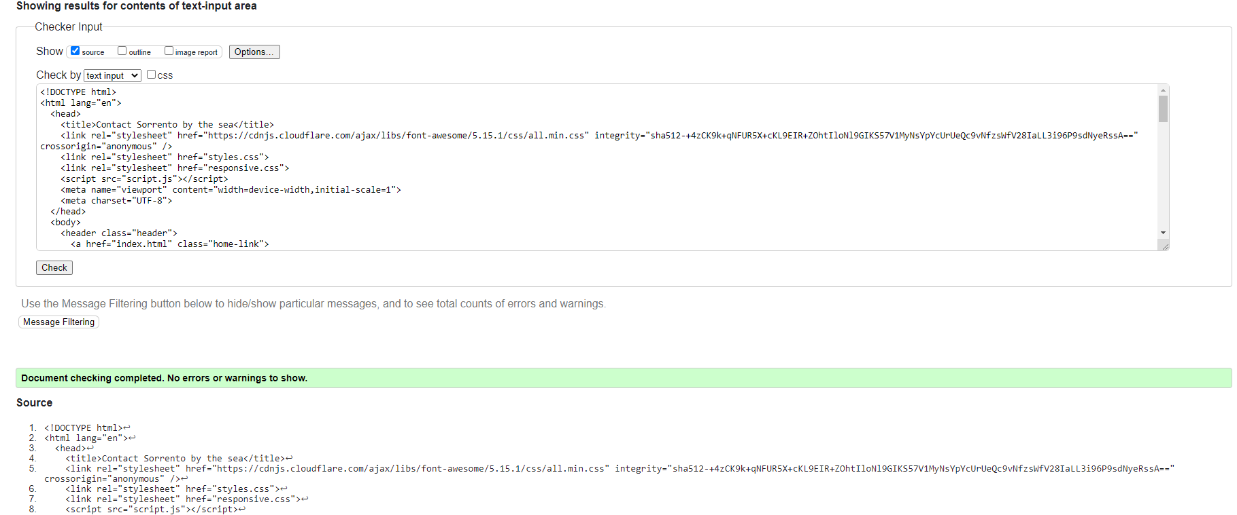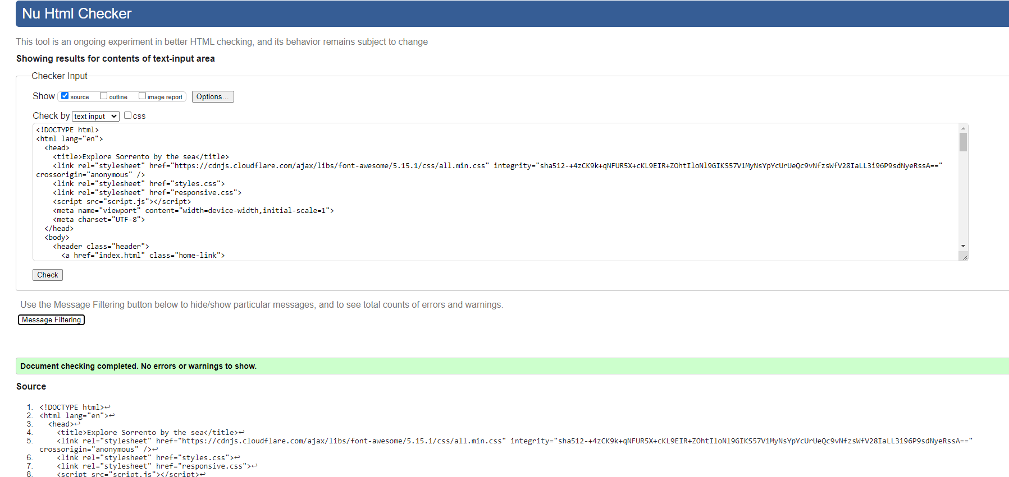

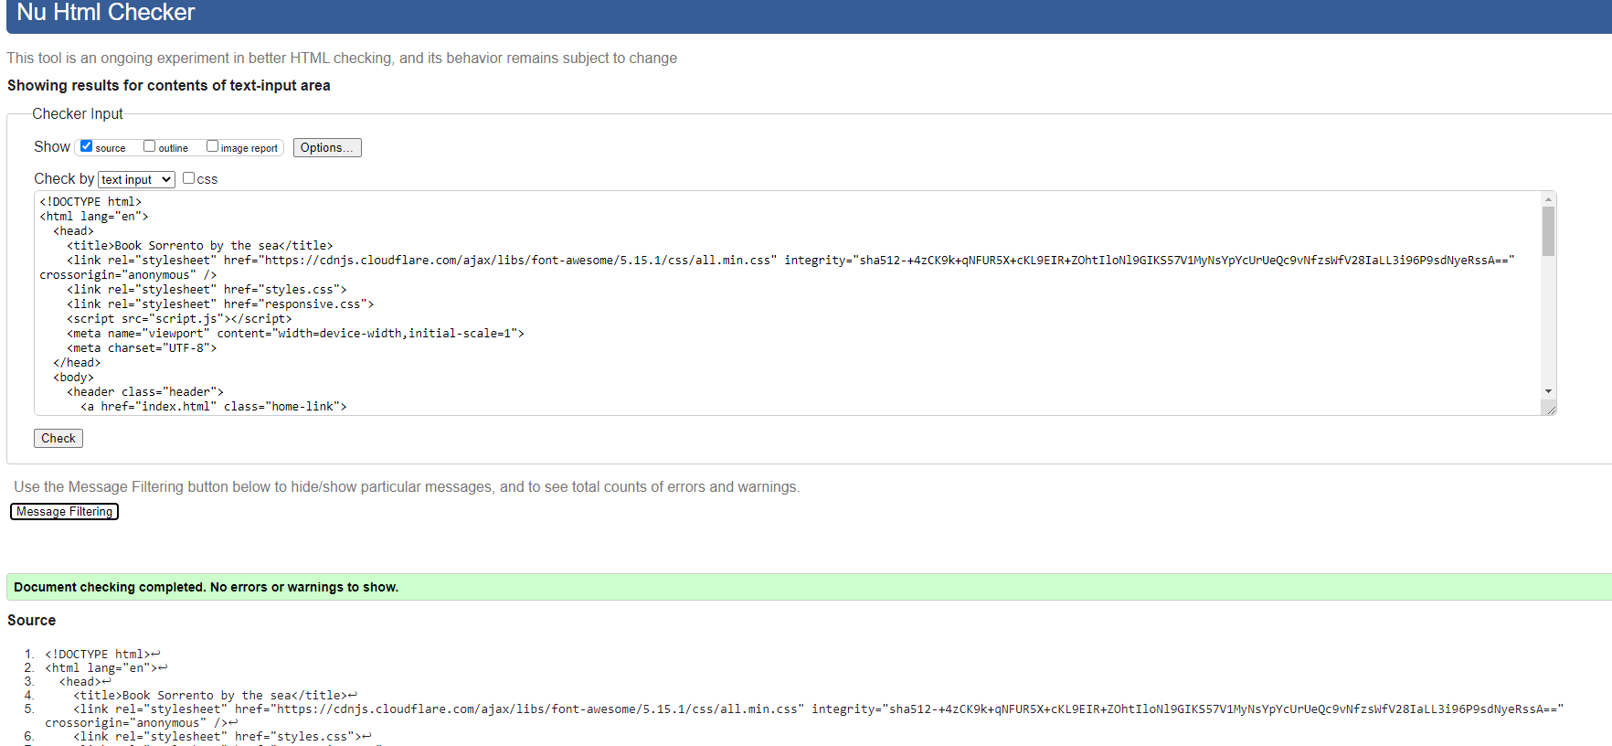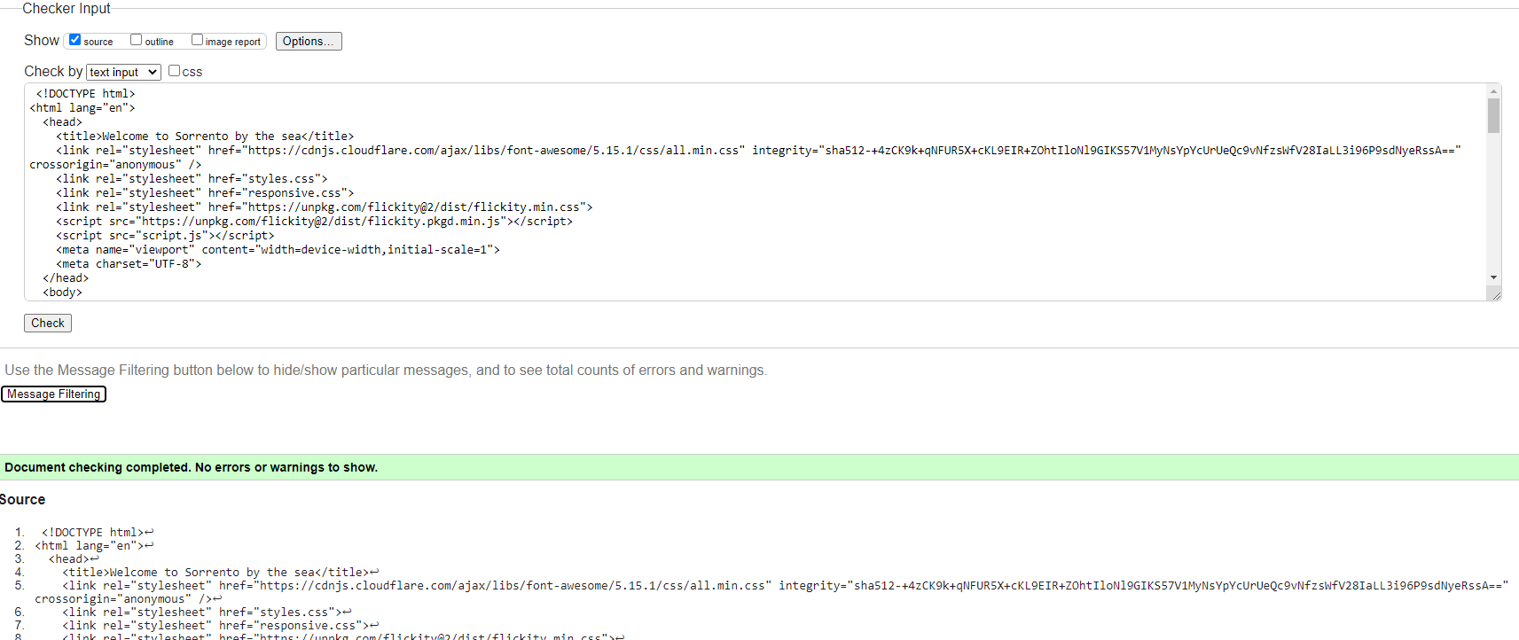All Webpages validated and the only alteration that needed to be made was the addition of the Alt Tags for any images that were attached.

Currently the website has a Mobile screen function set up, so the browser has no formatting issues between screen sizes.

The validated pages include:

Chrome

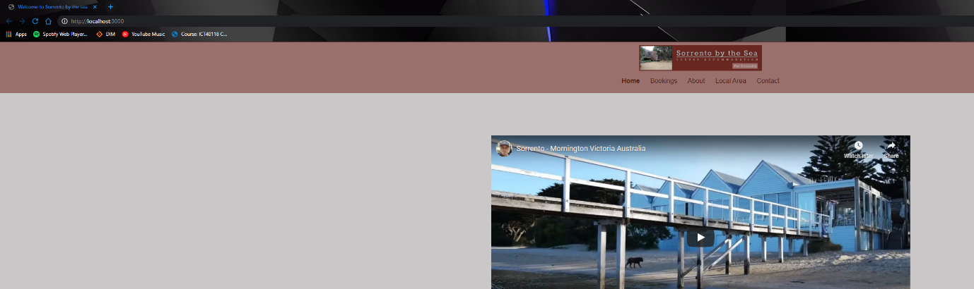

FireFox

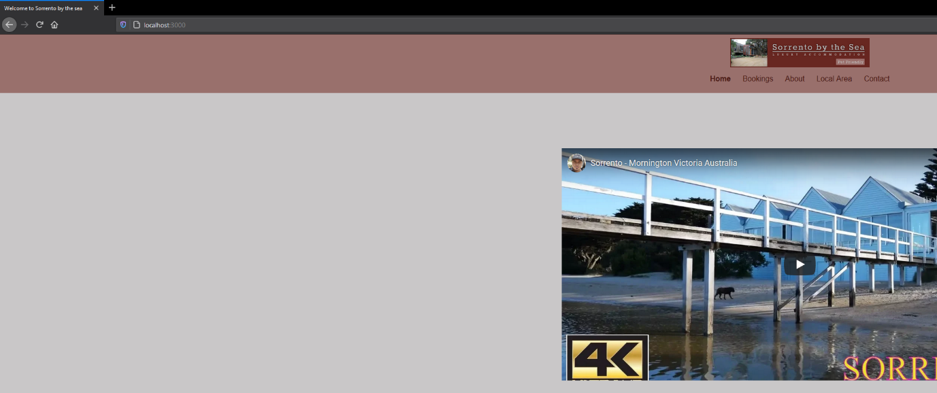

The process of validation was the act of taking all webpage codes and putting them into appropriate validating websites at <https://validator.w3.org/#validate_by_input>

After the webpage is confirmed to be validated it is ready for the customer. If it is not any appropriate changes are made to the code.

Part 4

|  |  |  |
| --- | --- | --- |
| Error | Solution | Action taken |
| Menu link broken on index | Make weblink same to page name | Menu link changed from menu to menu-page |
| Menu link broken on history | Make weblink same to page name | Menu link changed from menu to menu-page |
| Menu link broken on find | Make weblink same to page name | Menu link changed from menu to menu-page |
| Menu link broken on employ | Make weblink same to page name | Menu link changed from menu to menu-page |
| Menu link broken on community | Make weblink same to page name | Menu link changed from menu to menu-page |
| Menu link broken on menu-page | Make weblink same to page name | Menu link changed from menu to menu-page |
| Menu-page format broken | Move navigation out of header | Aside containing navigation moved to outside of header containment |
| Language tag missing from community.html | Add lang tag | Language tag of English added to community.html |
| Language tag missing from employ.html | Add lang tag | Language tag of English added to employ.html |
| Language tag missing from find.html | Add lang tag | Language tag of English added to find.html |
| Language tag missing from history.html | Add lang tag | Language tag of English added to history.html |
| Language tag missing from index.html | Add lang tag | Language tag missing from index.html |
| Image of map missing alt tag in find.html | Add alt tag | Alt tag “Map” added to image in find.html |
| Articles tag missing heading in menu-page.html | Link or remove article tag | Remove both article tags |

Community validation

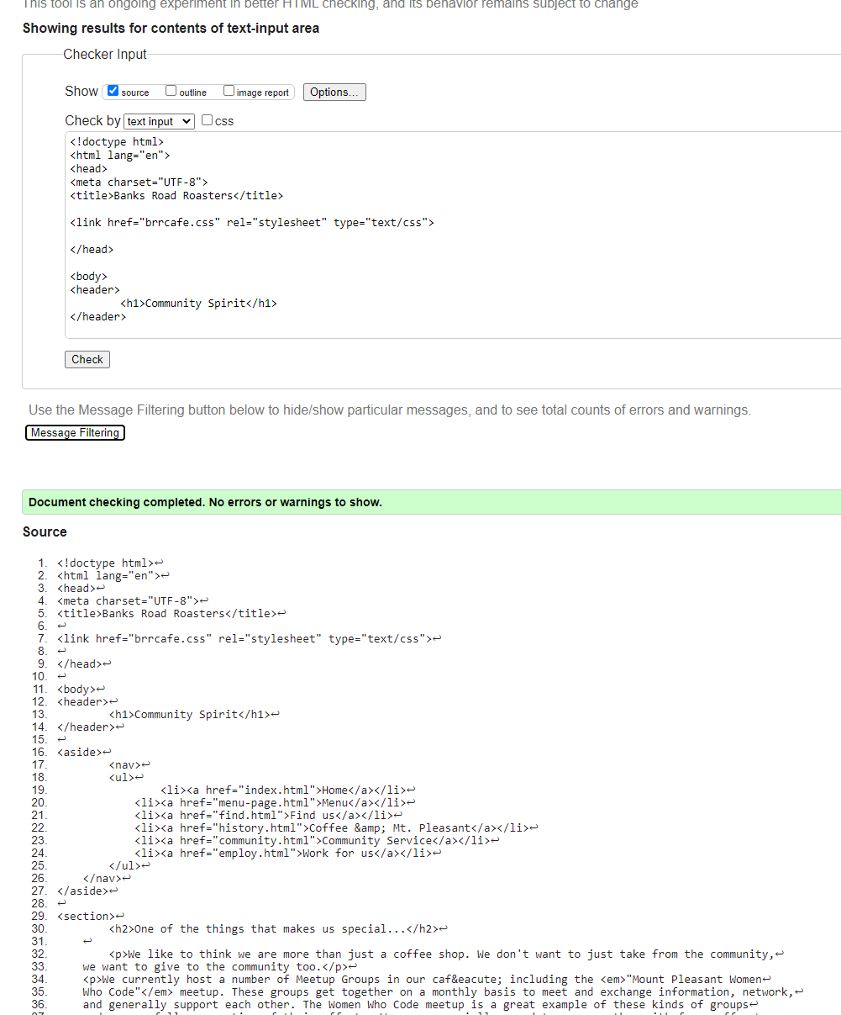

Employ validation

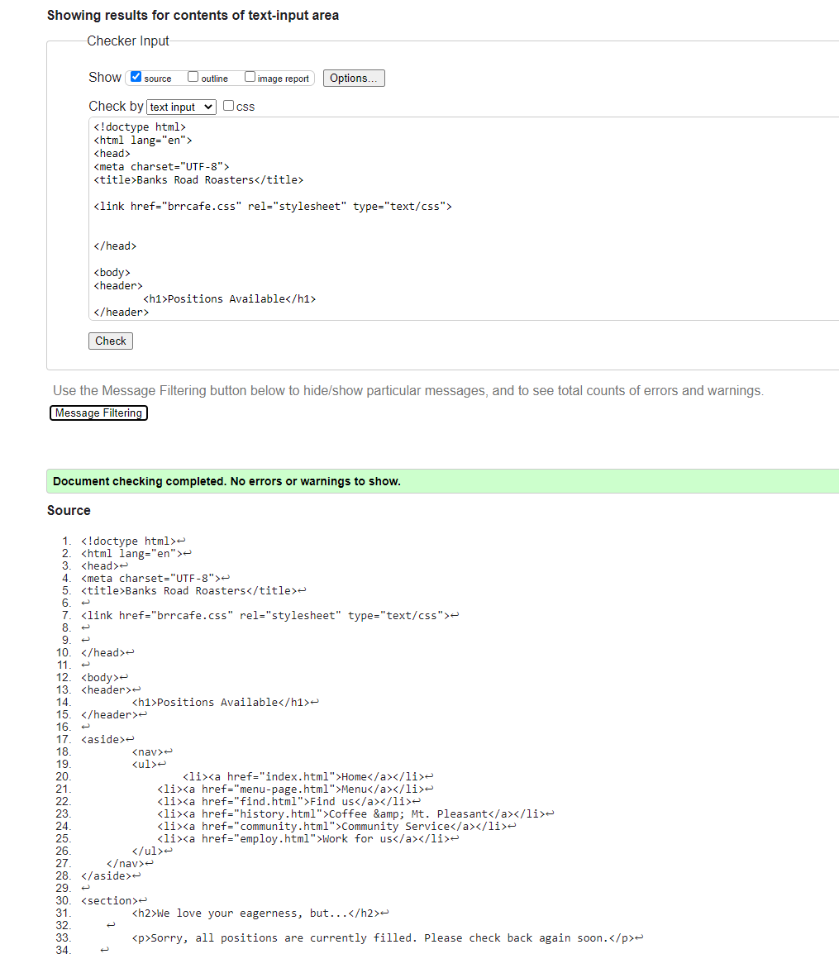

Find validation

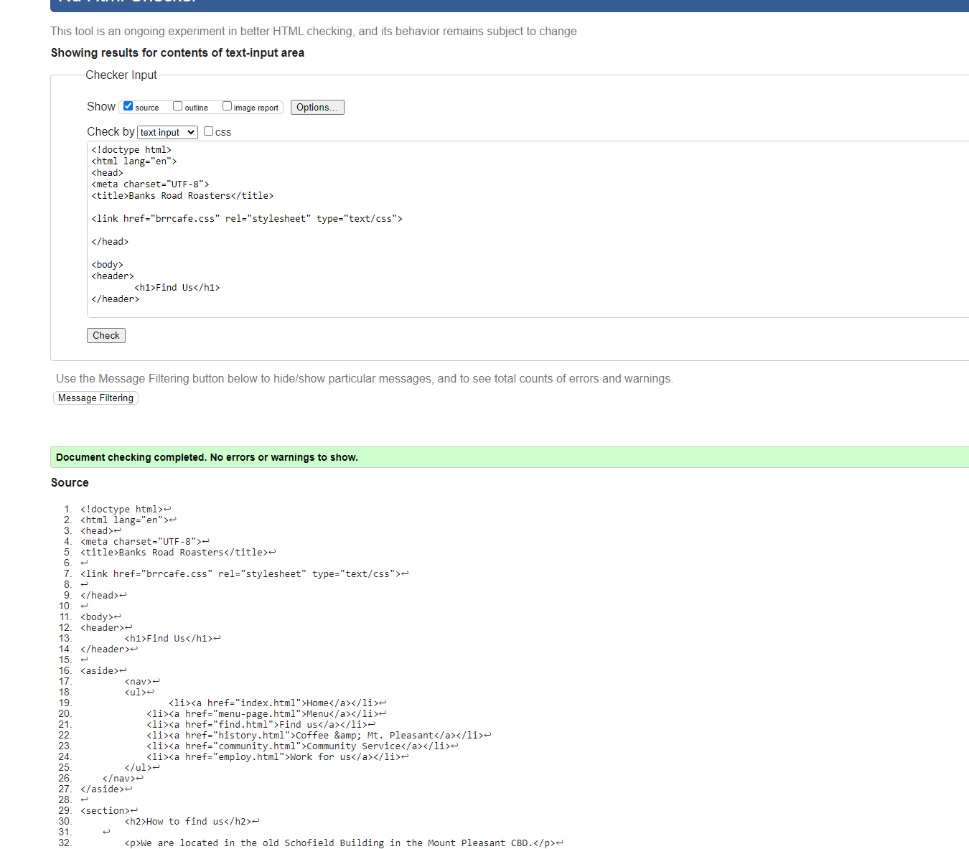

History validation

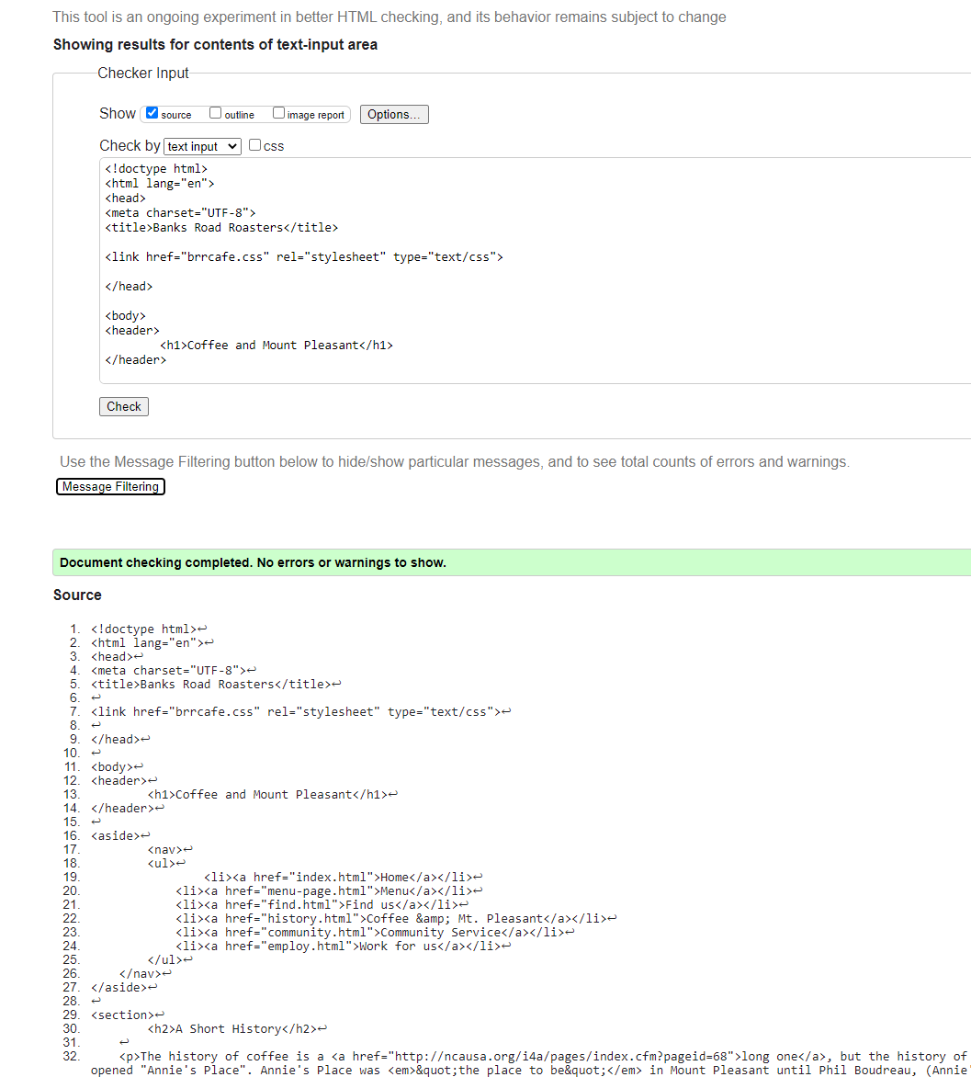

Index validation

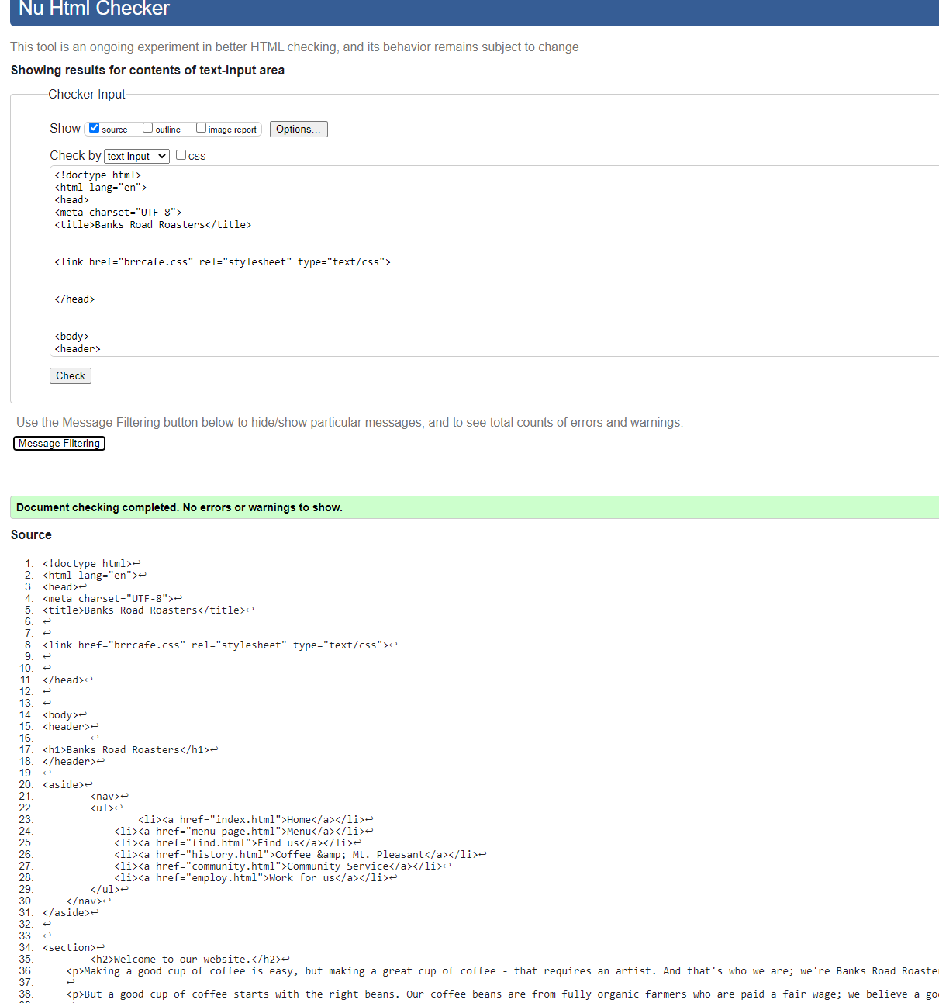

Menu-page validation

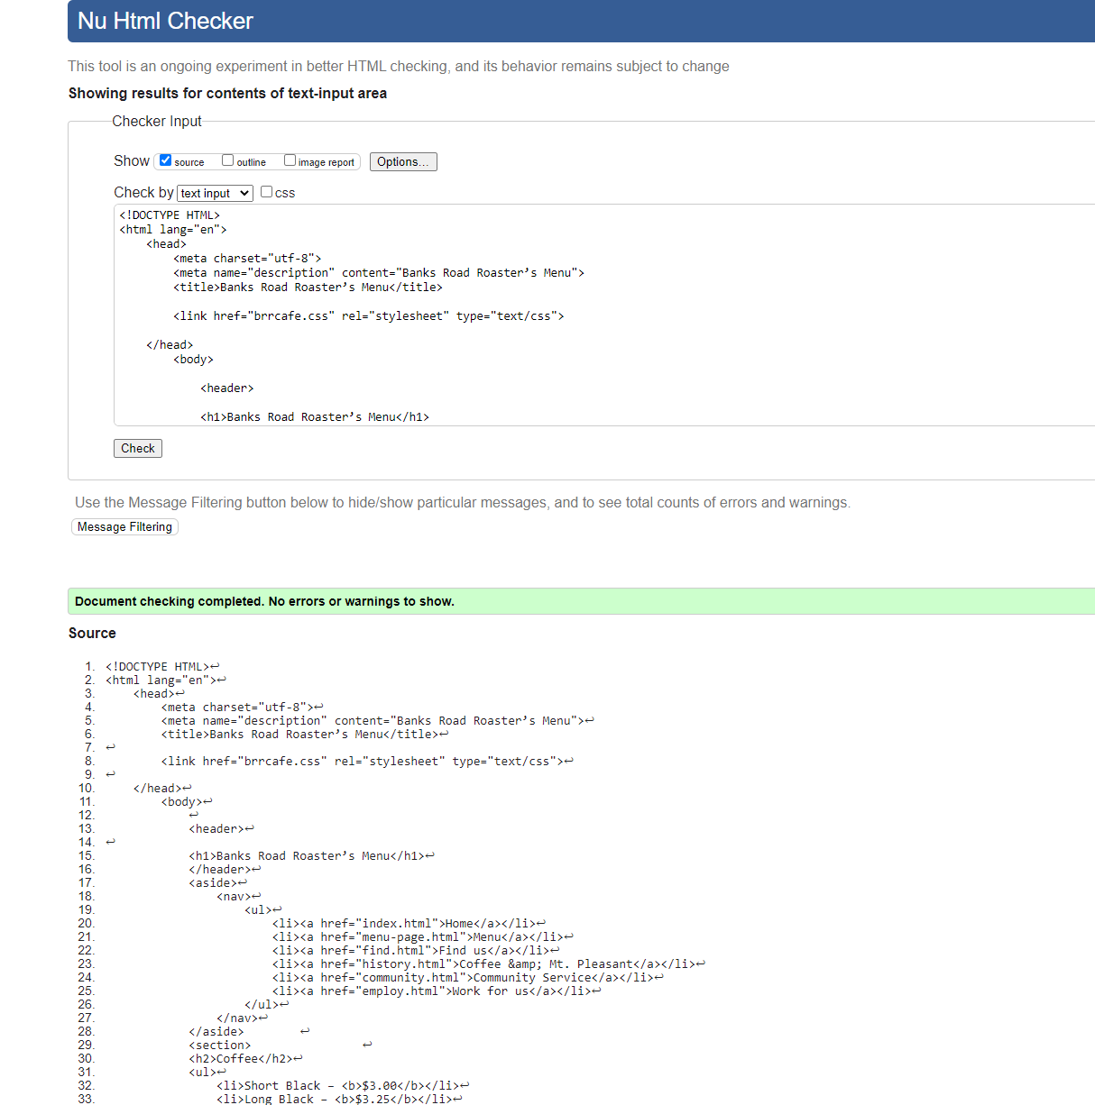

Css Validation

